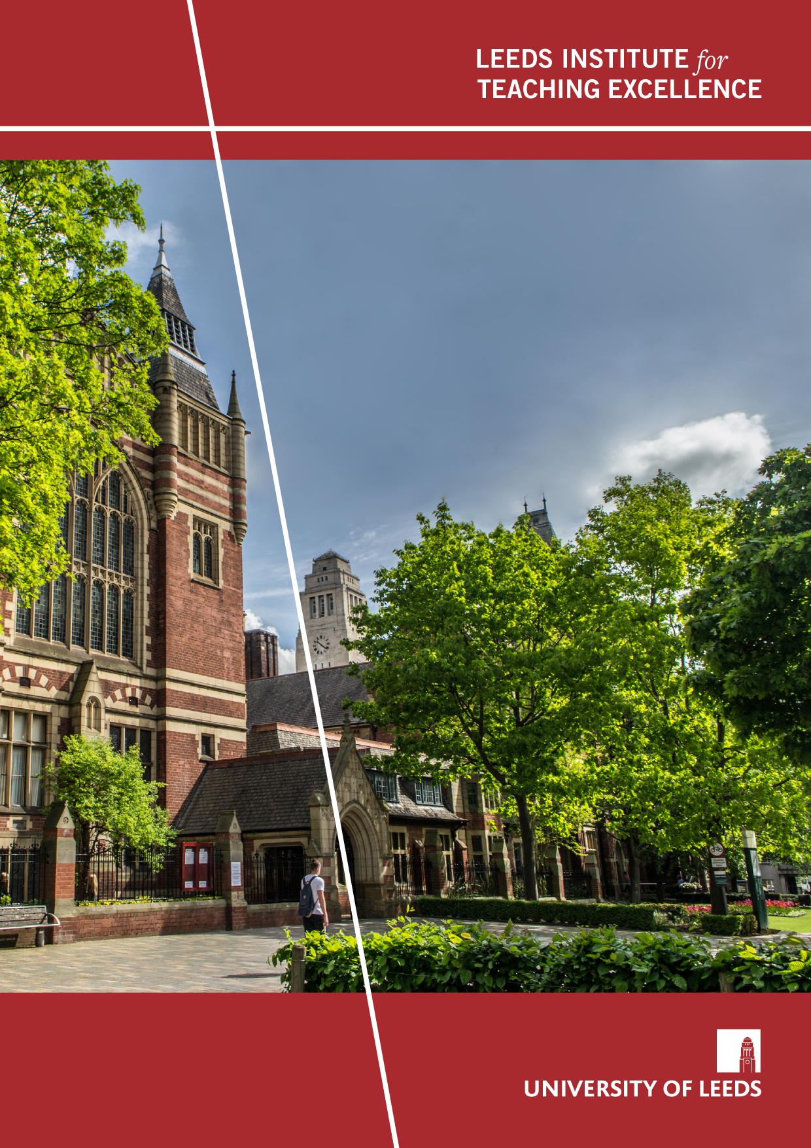
Internationalising student education at Leeds through embedding Collaborative Online International Learning (COIL)
Martin Ward, Ayako Yoshino, Eve Smith
Project Snapshot
August/2025

Project Overview
Collaborative Online International Learning (COIL) is a recognised pedagogy used at universities globally to develop students’ global citizenship and employability. It is one type of virtual exchange (VE), with the acronym ‘COIL’ having being coined by the State University of New York in the early 2000s (SUNY, no date). Surprisingly COIL has been underused in the UK, where Coventry University is the only university to have adopted it at scale. At Leeds we have committed to providing inclusive global study opportunities and developing engaged global citizens (International Strategy 2020-2030) and COIL is one way of facilitating this. In an era of huge geopolitical shifts, supporting the development of students’ global citizenship has arguably never been more crucial.
This project had two main goals. The first was to research barriers to COIL perceived by academics at Leeds and elsewhere in order to inform solutions to these barriers. The second goal was to capture the perspectives of students at Leeds regarding the potential for, and value of, embedding COIL at scale into the curriculum. The existing and growing body of literature has clearly demonstrated the benefits of COIL for students (see Oenbring & Gokcora, 2022; Naicker et.al. 2021; Ketteringham et.al. 2022​ amongst others) but awareness of this methodology at our institution, and as a result implementation, was limited. Ultimately this project sought to provide an empirical foundation to support broader uptake of COIL at Leeds.

Project Objectives
- Underpin the scaling up of COIL at Leeds using evidence-informed approaches
- Identify barriers to COIL at Leeds and ascertain student expectations for international experiences within the curriculum
- Establish COIL as a recognised pedagogy at Leeds with a COIL community of practice

Methods

Key findings

Remote teaching during the pandemic sparked increased interest among academics in implementing COIL-type pedagogies, equipping them with skillsets required for COIL.

Colleagues felt that previously institutional support structures were lacking and there was no clear roadmap for those who were interested in COIL.
- While Leeds already had a very small number of COILers, the practitioners were isolated due to the lack of community of practice, leading to duplicated efforts.

Students highly valued the opportunity to engage in international collaborative experiences as part of their university education.

While students anticipated challenges in group work, they expressed enthusiasm for participating in international collaboration through COIL.

Implications for practice
How can others use your research findings to inform and benefit their practice? How might they inform developments to university policy/strategy? What are your evidence-based recommendations?
- COIL is of strategic importance to student education at Leeds as it aligns with the institution’s international strategy and student education strategy (e.g. experiential learning)
- Leeds students expect and value an internationally-oriented curriculum which COIL can enable
- As demonstrated through the newly created COIL community of practice, harnessing diverse expertise is vital for institution-level pedagogic change

Collaboration between academic and professional service colleagues is crucial to enable the embedding of COIL as a foundational element within the institution's educational framework.

Outputs
From our project we produced the following resources:
- COIL Sharepoint to support the proliferation of COIL at Leeds
- A set of four infographics to guide colleagues in supporting and implementing COIL
- A chapter in the University of London conference proceedings for the RIDE2025 (Research in Distance Education and e-Learning) conference (pending publication)
- Poster for SEC 2024 (Student Education Conference): Embedding COIL ± in student education at Leeds

Challenges
Recruiting student participants for the survey proved unexpectedly difficult even though we offered incentives. Survey fatigue among students was a clear barrier, likely due to the volume of research participation and feedback requests they regularly receive in their inboxes. Anticipating this, we printed and displayed posters around campus, which helped improve engagement.
The volume of focus group data collected was also a challenge. The data was rich and insightful, but time-consuming to analyse. This process is still ongoing.
The LITE Fellowship stretched our individual skillsets. We not only conducted a scholarship project and gave papers, but also designed infographics, shot videos and organised showcase events. As a team of three we supported each other well, sharing our strengths, but at times, scheduling could become a challenge. On reflection, we might have given more time to the interview data analysis and creative outputs.
Future researchers should anticipate the recruitment challenges noted above and consider creative outreach strategies.

Next steps
This LITE project was research intensive, generating a significant amount of data. This means that there is significant potential for further development, and there are a number of avenues to pursue. The main aim of this project, proliferation of COIL, remains. However, there are now two main strands to this work, Firstly, supporting colleagues both within the university and externally, to explore and develop COIL. While a great deal of work has already been done in terms of creating training and networking opportunities, this is work that needs to be maintained.
Secondly, to further develop the COIL scholarship undertaken at Leeds. From this project we would like to work on further outputs with the data already gathered. The focus groups have generated a significant amount of qualitative data. While headline data has been used, an additional level of analysis could be done to consider how different groups “talk about” COIL. As a part of this it would be useful to do a further student focus group, with students who have COIL experience.

Selected Bibliography
Ketteringham, M., Shiel, J., Valavanis, A., Pursani, L., Hollins, A., Zhuang, S., & Shen, Y. 2022. Using the transnational setting to develop the intercultural communication skills of electronic and electrical engineering students. In Proceedings of the 8th International Symposium for Engineering Education Article 7206 University of Strathclyde. https://doi.org/10.17868/strath.00082037
Naicker, A., Singh, E. and van Genugten, T., 2021. Collaborative online international learning (COIL): Preparedness and experiences of South African students. Innovations in Education and Teaching International, pp.1-12.​
Oenbring, R., & Gokcora, D. 2022. COILing diverse islands: a virtual exchange between the University of the Bahamas and the Borough of Manhattan Community College. Journal of Virtual Exchange, 5, 20-30. https://doi.org/10.21827/jve.5.37388​
Prior, C. and Jager, S., 2022. The Implementation and Sustainability of COIL at Research and Research-Aspiring Universities. In The Guide to COIL Virtual Exchange (pp. 352-369). Routledge.​
SUNY, no date. Collaborative Online International Learning (COIL) [Online] Available from https://coil.suny.edu/​
University of Leeds, no date. University of Leeds Strategy 2020 to 2030: International. [Online] Accessed 2.5.25. Available from: https://spotlight.leeds.ac.uk/strategy-international/index.html
University of Leeds, no date. University of Leeds Strategy 2020 to 2030: Student education. [Online] Accessed 2.5.25. Available from: https://spotlight.leeds.ac.uk/strategy-student-education/index.html
Ward, M. and Tobias, S., 2024. New Prospects For International Telecollaboration In Translator Training: A case study on Leeds-Monash collaboration. In Teaching Translation (pp. 166-182). Routledge.​

