Locating and Cultivating Community in Fully Online Learning Environments: image full text description
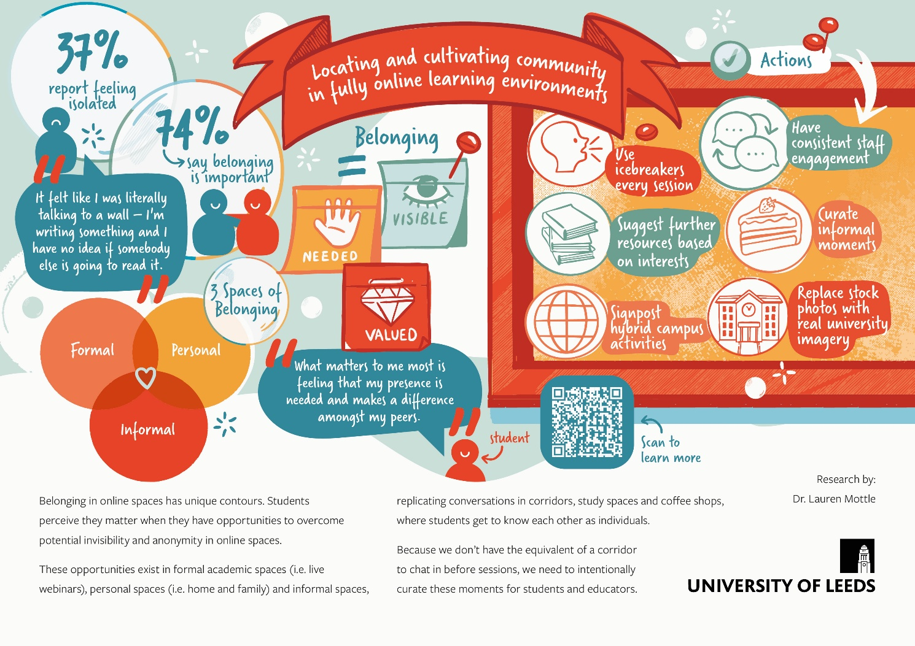

Image description
This image summarises the key findings of a research project in the form of a artistic and visual abstract. To frame the research, the image includes the following points.
74% of student participants reported that a sense of belonging was important during their studies. However, 37% reported feeling isolated during their studies. The image contains a quote from a student that says: “it felt like I was literally talking to a wall – I’m writing something and I have no idea if somebody else is going to read it.”
Student participants experienced belonging in three main spaces. Formal academic spaces, such as live webinars, personal spaces such as those involving home and family and informal spaces that replicate conversations in corridors, study spaces and coffee shops where students to get to know each other as individuals.
Student participants defined belonging as feeling needed, visible and valued. They perceived they matter when they have opportunities to overcome the potential invisibility and anonymity in online spaces. The image contains a quote from a student that says: “what matters to me most is feeling that my presence is needed and makes a difference amongst my peers.”
Belonging in online spaces has unique contours, and moments of connection must be intentionally curated. The image suggests the following action steps to cultivate community in fully online learning spaces.
- Use icebreakers every session
- Suggest further resources based on student interests
- Signpost hybrid campus activities
- Have consistent levels of staff engagement through a module
- Curate informal moments of connection
- Replace stock photos in teaching materials will images of the university.

