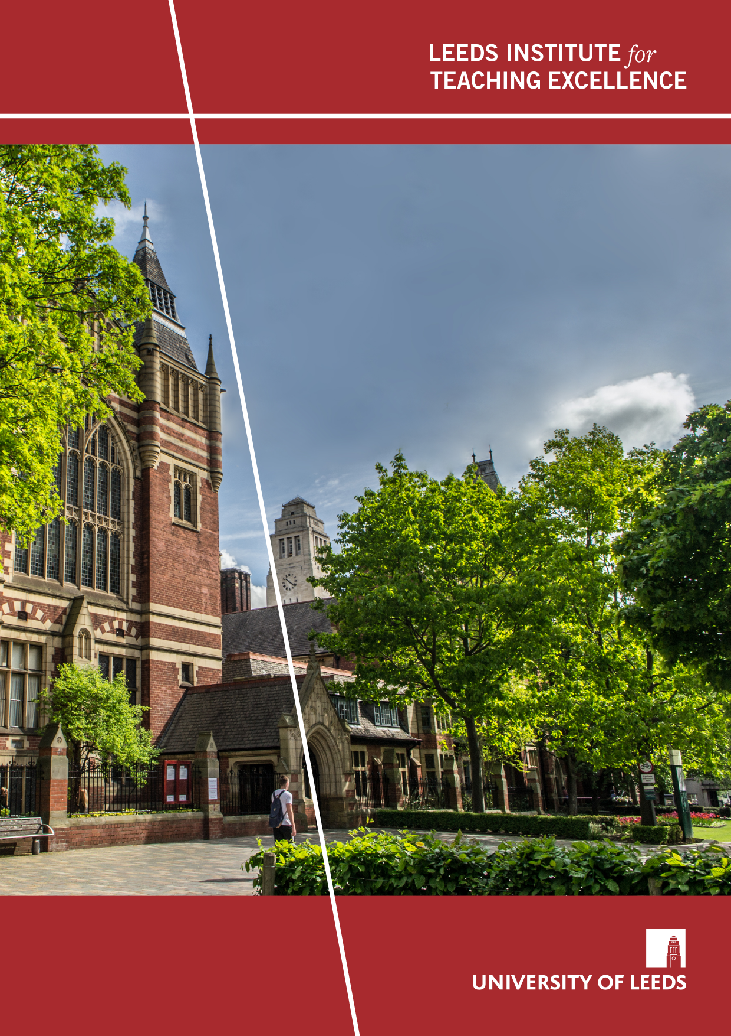
Evaluating the impact of a pedagogical framework for fully online education
Samantha Stark
Project Snapshot
November 2024

Project Overview

The Online Learning Team at the Digital Education Service (DES) works with academics from across the University of Leeds to create fully online master’s degrees in a variety of disciplines.

The purpose of this project was to evaluate the effectiveness of a new pedagogical framework for the design of online master’s degree modules. A new framework was deemed necessary as DES’ previous model of design, which was more of a blank paper approach, resulted in:

- too much content which overwhelmed learners,
- too much time needed to develop content for modules,
- a predominance of passive learning.

Background
Our online modules consist of six units in six weeks, with each unit containing 20 hours of learning.

Before the pedagogical framework, these 20 hours of learning were split into approximately four lessons, each containing various activities including reading, watching videos, listening to podcasts, participating in discussions, and completing reflections.

The framework changed this approach in several ways. First and foremost, instead of designing activities for the full 20 hours of learning each week, we only designed activities for 10-12 hours, allowing the remaining 8-10 hours for learner-guided learning. This allowed learners more autonomy and independence to plan their own learning activities in accordance with their own needs and preferences.

The second major change was that, instead of splitting the learning time into lessons, we split it into three main phases, namely:

- Prepare: 2 hours consisting of learning activities that will prepare learners for the next phase.
- Apply: 3-5 hours consisting of a substantive activity with a specified outcome, e.g. a coding challenge, a SWOT analysis, or a design activity. A group discussion was also included here for learners to share and discuss their outcomes.
- Reflect: 4 hours, consisting of webinar prep (1 hour), a synchronous webinar (1 hour), and a 2-hour reflection activity.

Another 1-2 hours was also reserved for a substantive discussion each week, the purpose of which was to engage learners critically in a topic related to the unit’s learning content. This discussion could take place before or after the Apply phase.

This framework is underpinned by three pedagogical principles, namely:
- Laurillard’s conversational framework (Laurillard, 2002)
- Constructive alignment (Biggs, 1999, 2003)
- Universal Design for Learning (UDL) (Rose & Meyer, 2006)

Project Objectives
The main objective of the project was to find out whether the new pedagogical framework was achieving its aims to:

- Reduce the amount of teaching content, thereby shortening development times and reducing workload,
- Improve staff and learner satisfaction with the modules.

A further objective was to find out how the framework could be improved.

Methods
I collected data in relation to modules that were designed with and without the new pedagogical framework, and from the key stakeholders involved in those modules, namely:

- DES staff involved in the design and development of those modules,
- Academic staff who had designed and developed those modules with DES, and
- Learners.

I used different data collection and analysis methods for the different stakeholders:

- DES staff: I organised two focus groups, one with grade 6 staff and one with grade 7 staff. This format allowed for interesting discussions around the framework and how it could be improved.
The data collected was categorised as follows for the purposes of analysis:
  - Satisfaction with the module,
  - Job satisfaction,
  - Workload,
  - Improvements,
  - Comparison with the previous design approach.
- Academic staff: I conducted one-to-one semi-structured interviews to allow staff the opportunity to describe their experiences and offer critical feedback on the process and design framework used.
I analysed the data from the interviews by building a corpus from the transcripts and then analysing the content using corpus software called AntConc (Anthony, 2023), searching for key terms and using the concordance function to explore the context. This allowed for trends in the data to be analysed objectively and efficiently.
- Learners: I designed an online questionnaire for learners to complete anonymously. This was the most practical method of data collection as our learners are spread across the globe in different time zones, and anonymity meant learners could express their views freely.
Due to the low response rate, I was able to analyse the data from these questionnaires manually by summarising the data in a table for ease of comparison.

Key findings
- The new pedagogical framework has:
  - made module design and development quicker in general, but speed still depends on other factors,
  - worked to control the amount of teaching content,
  - resulted in more active, learner-focused content.
- The framework has not necessarily reduced workload due to:
  - the time needed to create good substantive activities for the Apply phase,
  - the impact of the level of experience academic and DES staff have.
- The framework can lead to lower levels of satisfaction if it is applied too rigidly or uniformly.
- While content has reduced, the amount of work learners need to do can still be overwhelming for them, which can impact engagement.
- Making some of the suggested improvements could help the framework to better achieve some of its goals.

Implications for practice
Based on my findings, it is recommended that the following improvements are made to the way in which the pedagogical framework is used. Some of these recommendations could also be applied to any framework or structure that is used for the purposes of online course design:

- More flexibility in the way in which the framework is used so that:
  - parts of the framework that are not as useful to some disciplines can be removed or replaced, e.g. discussions and end-of-unit reflections,
  - more active learning interventions can be included in the Prepare phase, so that learners are more engaged and ready for the Apply phase,
  - substantive activities don’t have to begin in week 1 of a module, so that learners have more time to build confidence and a solid foundation in the subject,
  - the size of substantive activities can vary as needed to allow learners breathing space and time to do assessments, catch up, etc.
- Encourage engagement in the Apply phase by (e.g.):
  - writing feedback in such a way that it only makes sense to the learners if they have completed the substantive activity,
  - linking the Apply phase to the webinar,
  - linking the Apply phase for each week with the summative assessment(s), e.g. by asking learners to complete a learning log related to the substantive activity each week,
  - providing clear reasons for completing the substantive activity,
  - breaking down some of the substantive activities into component parts (where possible) to help learners who are time poor.

Outputs
I presented my findings at two conferences, namely:

- The Association of Learning Technology conference in September 2023. I presented with Simon Carrie from DES, and our presentation received really good feedback (no link available).
- The Student Education Conference at the University of Leeds in January 2024 (recording (from 2:34)).

I also recorded a podcast discussing the research, findings and recommendations with Emma Peasland as part of the LITE Bites podcast series, which will be published early in 2025.

Challenges
I encountered two main challenges during the research process, one which was outside of my control, and the other which was entirely my fault!

The first challenge was that one of the modules on which I was collecting data was postponed, so it was no longer running during my data collection period. This module was one of the ones piloting the new framework, so it was really important for my research, as the number of such modules was already limited. This meant I had to delay my data collection and collect data from modules on a different degree programme. The effect of this was that it was not possible for me to complete my fellowship within the allotted time, despite being given an extra month to complete it. I therefore had to find time to complete my analysis during my normal working hours, which was challenging.

The second challenge was caused by the fact that my original research questions were not very well written. This made it more difficult for me to design my questions for data collection, and it resulted in some of the questions being unclear, particularly for the focus groups. Thankfully, given the data collection formats I chose, I was still able to collect useful data so I could draw some valuable insights. However, I might not be so fortunate in future research projects, so I will spend a lot more time on drafting research questions from now on, ensuring that the questions are precise and are capable of being answered by the data collected.

Next steps
I have now left the team that designs online master’s degrees, but it would be useful to revisit how the pedagogical framework is being applied and received now that it has been in use for over two years. I would be particularly interested to hear about whether the insights gained from my research have positively impacted how the framework is used, and whether any further improvements or adjustments are needed. If anyone from the Online Learning Team would be interested in discussing this with me, then please do get in touch.

Bibliography
Include useful literature/resources including, but not limited to, anything you’ve cited in the snapshot.

Anthony, L. (2023). AntConc (Version 4.2.4) [Computer Software]. Tokyo, Japan: Waseda University. Available from https://www.laurenceanthony.net/software

Biggs, J. (1999) What the student does: teaching for enhanced learning, Higher Education Research & Development, Vol. 18(1), 57—75. DOI: 10.1080/0729436990180105

Biggs, J. (2003) Aligning teaching for constructing learning, Higher Education Academy, Vol. 1(4), 1—4

Laurillard, D. (2002) Rethinking university teaching: A conversational framework for the effective use of learning technologies. Routledge

Rose, D. and Meyer, A. (Eds) (2006) A practical reader in Universal Design for Learning. Harvard Education Press

Acknowledgements

I would like to thank the following people for helping to make my LITE Fellowship a success:

- Hayley Bullard at LITE for running the focus groups and her qualitative data analysis of the focus group transcripts.
- Daniel Popple in DES for providing insightful numerical engagement data.
- The academics, DES staff, and students who participated in the research.
- Dave Riley, Emma Peasland and the LITE team in general for their help and support.

