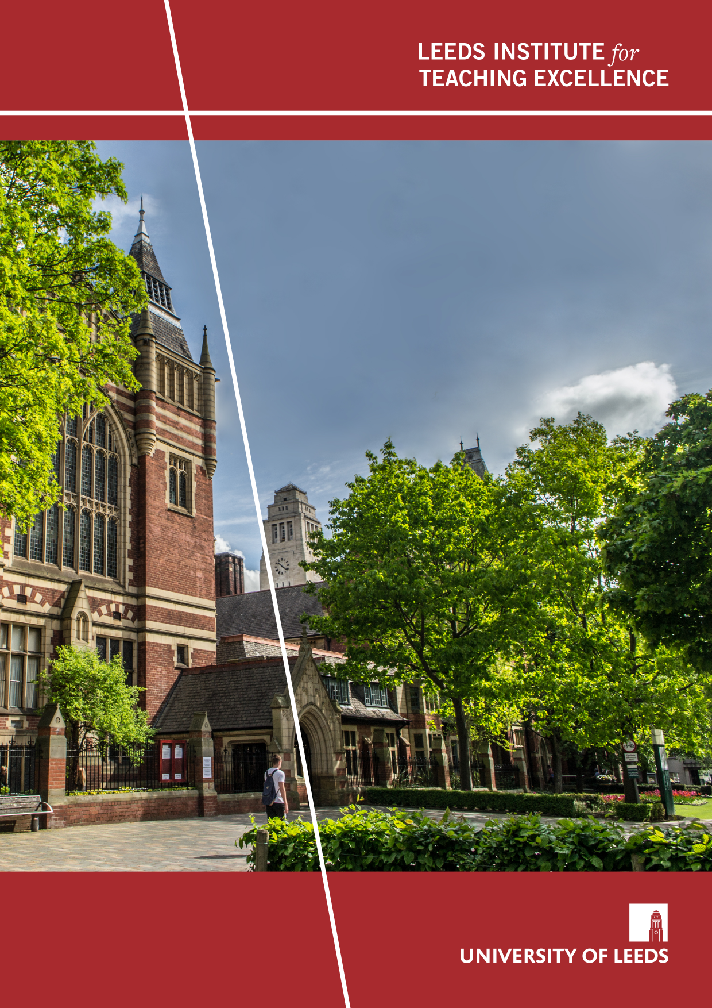
Academic Integrity Strategies: Positive, Preventative and Punitive
Caroline Campbell & Lorna Waddington
Project Snapshot
December/2024

Project Overview
We wanted to investigate the complex area of academic integrity with a view to developing and embedding a culture of academic integrity. We hoped to develop strategies to support a positive student environment and encourage students to study with integrity. We wanted to focus on three areas – positive, preventative and punitive strategies. Our findings would inform the development of strategies in the following areas:
- Innovative, effective practice in informing and educating students about academic integrity
- Developing students’ understanding of plagiarism and all that entails
- Training and support for staff in developing their awareness with a focus on detection and investigation of plagiarism
- Exploring the ever-increasing threat of contract cheating, with a focus on the importance of detection.
Working with students, we wanted to investigate their awareness and understanding of academic integrity and evaluate the current information and training available. This would identify the issues and help determine where we can improve our practice, develop new resources and recommend training for students and staff. We employed two Student Researchers and benefitted from their insights, their suggestions and their experience as students.

Project Objectives
- To review policies, resources and training, identify and investigate gaps, and inform our practice
- To investigate the area of contract cheating and consider this threat in terms of our duty of care to our students
- To join relevant networks, attend relevant events and share principles and approaches; to be able to advise, revise, refresh and recommend both internally and externally

Methods
- A systematic literature and policy review
- A student survey (conducted in 2020-21, 2021-22 and 2022-23)
- Focus groups with students (Nov-Dec 2020) run by the Student Researchers
- A staff survey (conducted in 2021-22 and 2022-23)
- Thematic analysis

Key findings
- Global Strategy Development:
There is a need for global cooperation to develop robust strategies, ensuring the maintenance of academic standards and the reputation of academic awards worldwide.
- Institutional Responsibility and Collective Involvement:
Academic integrity is an institutional concern requiring the active participation of all members, including academics and students. We need to foster a culture where everyone is involved in upholding and promoting integrity standards, ensuring comprehensive support and accountability across the institution.
- International students:
International students are significantly overrepresented in academic misconduct cases within the HE sector. This underscores the need to create an inclusive, supportive academic environment addressing international students' unique challenges, particularly in understanding academic integrity norms in a UK context.

Implications for practice
- Institutions need to design student and staff training on academic integrity, updated annually to reflect emerging trends, and ensure that the training is completed, in order to establish a baseline of knowledge.
- There is a clear need for regular updates and activities to deliver policy and good practice in terms of assessment design, to promote academic integrity, to identify academic misconduct, and to work with our students to educate and support in a digital age.
- Institutions benefit hugely from working together both in the UK and globally to share approaches and address emerging challenges as we strive to maintain the value of Higher Education in the age of artificial intelligence.

Outputs
Campbell C, Haikney E, Waddington L. (2024) ‘Collusion: The New Norm?’, Ethics and Integrity in Educational Contexts.

Campbell C, Waddington L. (2024). Academic Integrity Strategies: Student Insights. Journal of Academic Ethics. 33-50 22.1

Weber-Wulff D, Anohina-Naumeca A, Bjelobaba S, Foltýnek T, Guerrero-Dib J, Popoola O, Šigut P, Waddington L. (2023). Testing of detection tools for AI-generated text. International Journal for Educational Integrity. 19.1

‘Researching Academic Integrity: Designing Research to Help Participants Give Genuine Responses Using Quantitative and Qualitative Methods’, Academic Integrity: Broadening Practices, Technologies, and the Role of Student, (2023). Authors: I. Gaizauskaite, L. Waddington et al.

ENAI newsletter, (2022). ‘Contract Cheating Checklist for Markers’, O. Popoola and L. Waddington https://mailchi.mp/2b2cec5131ce/august2022
https://teachingexcellence.leeds.ac.uk/wp-content/uploads/sites/89/2022/01/Academic-Integrity-Essay-Mills-with-logo-1.pdf (2022) (created by students)

https://teachingexcellence.leeds.ac.uk/wp-content/uploads/sites/89/2024/02/Academic-skills-resource-for-students.pdf (2022) (created by students)

QAA report: ‘Digital assessment security: Advice on online invigilation and other solutions for ensuring good academic conduct in online assessment’, (2021). (S. Bullock, L. Waddington et al.)

‘Contract cheating detection for markers: checklist’ (2021). O. Popola, L. Waddington et al. https://www.aber.ac.uk/en/media/departmental/cdsap/cpdmaterials/contract-cheating-checklist.pdf

https://teachingexcellence.leeds.ac.uk/blog-the-importance-of-academic-and-personal-integrity-for-students/ (2021). C. Campbell and L. Waddington
https://teachingexcellence.leeds.ac.uk/combatting-the-threat-of-contract-cheating/ (2021) C. Campbell and L. Waddington
‘IDOA Student Committee’s Jeopardy on Contract Cheating: A review and helpful guide to using the game’, (2021). Z. Khan, L. Waddington et al.
https://academicintegrity.org/blog/73-2021/november-2021/326-idoa-student-committee-s-jeopardy-on-contract-cheating-a-review-and-helpful-guide-to-using-the-game

Campbell, C. & Waddington, L. (2020) https://teachingexcellence.leeds.ac.uk/blog-the-importance-of-academic-and-personal-integrity-for-students/

Challenges
During our research project, we encountered several significant challenges, particularly those arising from the Covid pandemic. The cancellation of the Dubai conference, in-person meetings, and student surveys significantly limited our opportunities for data collection and professional networking. Additionally, managing our time proved difficult as both partners had differing teaching schedules and held roles as School assessment leads, which introduced further time pressures. Protecting dedicated research time was challenging under these circumstances. To overcome these obstacles, we proactively pre-arranged as many meetings as possible in advance, allowing for better coordination despite our conflicting commitments. Other prospective LITE fellows can learn the importance of adaptability, proactive planning, and effective time management, especially when balancing multiple responsibilities and navigating unforeseen disruptions.

Next steps
Lorna Waddington: now the University's Academic Lead for Academic Integrity, continues to lead in this field, particularly regarding GenAI and academic integrity. Her recent work, ‘Navigating Academic Integrity in the Age of GenAI: A Historian’s Perspective on Censorship’ offers crucial insights and underscores the need for ongoing research in this area. She has also recently co-authored an article on the ethical use of GenAI in research that is available in pre-print. Lorna is also spearheading an international student project designed to cultivate an environment of academic hospitality. This initiative provides dedicated support in academic integrity and general academic skills, as well as cultural orientation and other areas identified in collaboration with our student partners.
Caroline Campbell: Since completing the Fellowship, Caroline has focussed on disseminating the findings (jointly with Lorna and individually) from the student and staff surveys in particular. She has recently authored a chapter based on the findings from the staff survey, to be published early in 2025 as part of the book series Ethics and Integrity in Educational Contexts.

Bibliography
S. Bjelobaba, L. Waddington et al., (December 2024), ‘Retaining research integrity in the age of GenAI: An analysis of ethical challenges and solutions.’ Pre-print: http://arxiv.org/abs/2412.10134
C. Campbell, [Forthcoming]. Academic Integrity and Staff Perceptions: Perspectives on students’ understanding of academic integrity, and staff needs in the age of artificial intelligence.
L. Waddington (November 2024) https://academicintegrity.org/resources/blog/536-navigating-academic-integrity-in-the-age-of-genai-a-historian-s-perspective-on-censorship

