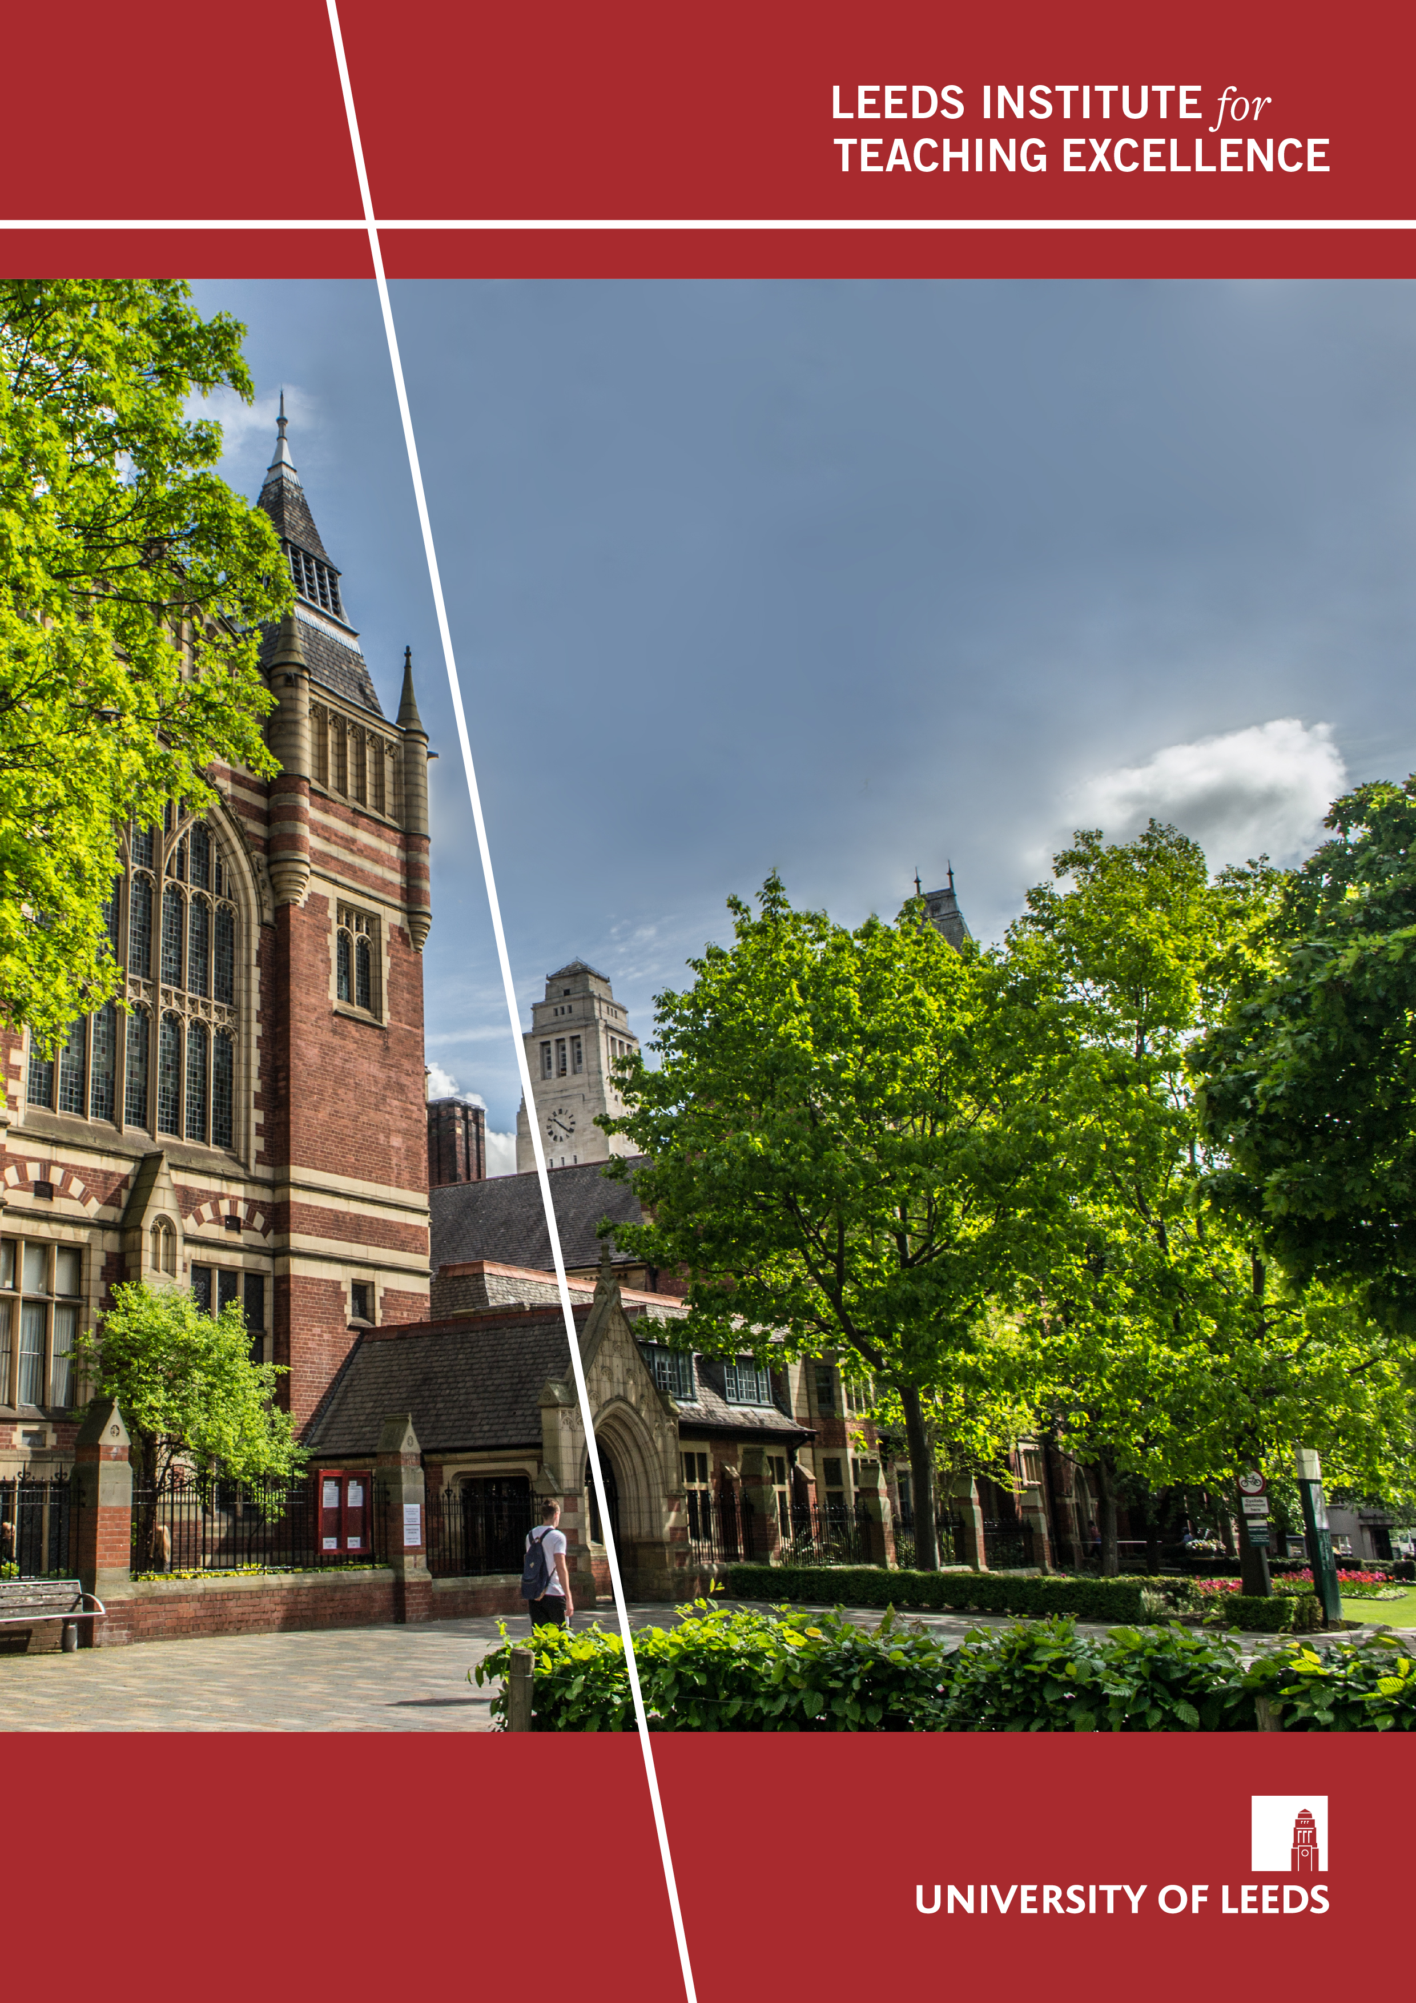
Project Overview

An interdisciplinary investigation of the construction, introduction, implementation, and impact of assessment criteria across schools at the University of Leeds
Undergraduate students’ and tutors’ perceptions of the assessment criteria: quality and challenges
Author: Dr Huahui Zhao
Project Snapshot
September/2020
Assessment in Higher Education has been given increasing attention globally due to its importance for learning and widespread concerns over students’ low satisfaction with it in the National Student Survey. Assessment criteria provide students and tutors with a shared understanding of what good work should be and therefore, play a pivotal role in enhancing assessment effectiveness and facilitating the quality of teaching and learning.
Effective implementation of assessment criteria needs negotiation, dialogue, and participation of the members of the assessment community. This community includes criteria creators (e.g. assessment officers), criteria implementers and users (e.g. tutors), and criteria beneficiaries (e.g. learners). As Bloxham and Boyd (2007, p.73) stipulated, “application of a marking scheme is a social construct negotiated between the members of that assessment community and influenced by their tacit knowledge”.
The cross-disciplinary project investigated how assessment criteria across schools at the University of Leeds were constructed, introduced, implemented and consequently impacted learning from the undergraduate students’ and staff’s perspectives. It elicited participants’ challenges and expectations of assessment criteria. As such, a wide community of practice across schools could be established to promote the effectiveness of assessment criteria and their positive impact on teaching and learning.

Project Objectives
The project expected to generate comparative and cross-disciplinary results of:
- how the assessment criteria were constructed, introduced, and implemented in different schools
- whether and how the criteria have informed and supported assessment practice and learning
- how the different processes of development, introduction, implementation, and the consequent usefulness of assessment criteria affected each other
- where improvements could be made, and support could be provided to harness the effectiveness of the assessment criteria at the University of Leeds
- what we could learn from the existing good practice of the construction, introduction, and implementation of the assessment criteria across schools.
In this way, the project aims to create an expansive learning environment (Hodkinson and Hodkinson, 2005) and communities of practice wherein colleagues could cross boundaries into other schools and openly share, closely collaborate, and learn from each other. The dissemination of results could also generate international impact on practice related to the assessment criteria, considering the emergence of global attention to assessment.

Methodology
Four research questions were asked:
- How were the assessment criteria constructed across schools in terms of their context, aims, and design?
- How were the assessment criteria introduced across schools in terms of resources, support and training that were provided for staff and students?
- How were the assessment criteria implemented across schools?
- How did students and staff across schools perceive the assessment criteria in terms of their accessibility, feasibility, usefulness, and challenges?
Multiple research methods were adopted to answer these questions, as shown in Figure 1. Document analysis was conducted regarding the university policies related to the assessment criteria, in comparison to the existing literature about the assessment criteria. Content analysis was carried out to compare the characteristics of the existing assessment criteria across schools. Interviews took place with different stakeholders across schools (including the Director of Student Education (DSE), assessment officers, module tutors and students) to elicit their perceptions and experience of the existing assessment criteria. Online and face to face surveys were conducted with second and final year undergraduate students, exploring their perceptions and experiences of the existing criteria in their schools.

Figure 1 Research methodology

Key findings
- Less than 10% of the 101 respondents across 22 different subjects claimed that they fully understood the assessment criteria in their programmes, were significantly affected by the wording of the assessment criteria, understood their relevance to the assessment tasks, and received tutor support for understanding them.
- Tutors explaining the assessment criteria in class was significantly related to students' understanding of what a good assignment should be, the usefulness of feedback for future assignments, and efforts of discussing feedback with peers.
- Collaboration between students and tutors, among colleagues, and between schools was believed to be inadequate but essential for the efficient implementation of assessment criteria.
- The four most influential factors for the ineffectiveness of the assessment criteria were (a) the inaccessibility of the assessment criteria, (b) tutors’ subjectivity in marking, (c) the great variance in assessment practice among staff and across schools, and (d) insufficient students’ and tutors’ engagement with assessment.
- Schools do devote time to promoting good assessment practice, including Leeds Expectations on Assessment and Feedback exercises initiated by the University, discussions in the school Teaching away days, and technology-assisted assessment with embedded rubrics. Yet, efforts were primarily focused on the consistency of marking among colleagues rather than how to use the criteria to enhance the facilitative role of assessment in teaching and learning.

Outcomes
The project has generated rich data that helped to produce very interesting results and develop my understanding of how the assessment criteria have been constructed, implemented, and challenged across different disciplines, from both students’ and staff’s perspectives. It has also provided insights into how students should be supported to understand and utilise the assessment criteria to facilitate their learning and assessment performance.
A conference abstract has been accepted by the Annual Conference on Assessment in Higher Education 2020 which has been postponed to 2021 due to the COVID-19.
I will produce a leaflet about the effective construction, introduction and implementation of the assessment criteria based on the good practice across schools. The leaflet will be finished with challenges stated by the staff and students to depict future directions for effectively utilising assessment criteria for teaching, learning, and assessment.
I had planned to deliver a workshop on assessment with colleagues from LITE which was cancelled due to the COVID-19. A colleague from SLCS and I delivered a seminar on this topic in the School of Education Scholarship Seminar on 22nd October 2020,
I am working on a draft academic journal papers about the assessment criteria based on the findings, including journals such as Assessment and Evaluation in Higher Education.
The project has also led to a larger project funded by the IELTS joint funding programme (IDP: IELT Australia and British Council) (≈ £45,000), exploring the impact of assessment in higher education on the predictive validity of the IELTS scores.

Challenges
The vast differences in the assessment criteria and related practice across schools led to difficulty in designing and administering one survey which fitted into all disciplines, based on the pilot. Therefore, the original plan to carry out a staff survey was changed to interviews. This, however, generated in-depth data.
Despite the flexibility of an online student survey, the response rate was low. Therefore, a face-to-face survey event was held across two days which generated nearly 100 responses, thanks to the three student research assistants, Diego Civitelli, Chloe Berry, and Venessa Waite.
The slight change of the focus allowed me to cover varied areas about the existing assessment criteria and related practice. The data were also applicable to more schools at the University of Leeds. The prompt changes of methodologies have generated rich data which helped to produce very interesting results.

Next steps
I will keep working on the topic of the assessment criteria, based on my completed LITE project and a project funded by the British Council which focused on the co-constructing assessment criteria for language learners. I will also work on the forthcoming IELTS joint funded project, starting from January 2021. The network that I established based on the LITE project will help me to reach potential participants across schools at Leeds.
I will keep looking for potential colleagues to deliver workshops on the assessment criteria to maximise the impact of the project on education practice within and beyond the University of Leeds.

Bibliography
Bloxham, S. and Boyd, PF. 2007. Developing effective assessment in higher education: a practical guide. Buckingham: McGraw-Hill Education.
Hodkinson and Hodkinson, 2005. Improving schoolteachers’ workplace learning. Research papers in Education, 20(2), pp.109-131.
Zhao H. and Zhao B. (2020) Co-constructing the assessment criteria for EFL writing by instructors and students: A participative approach to constructively aligning the CEFR, curricula, teaching and learning, Language Teaching Research, https://doi.org/10.1177/1362168820948458

